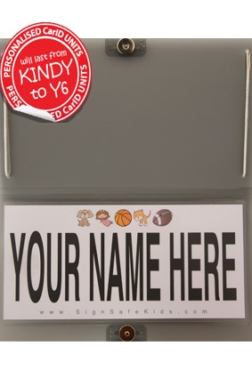

To ensure that our afternoon carline operates safely and efficiently, please go to signsafekids.com to order a
Car-ID from only $24.95.

The personalized unit will attach to the passenger side visor to display your family name clearly to the staff on duty.

Your unit will last from Kindy to Year 6, a one-off investment in the safety of all our carline families.

